**Ideation Phase**

**Define the Problem Statements**

| Date | 31 January 2025 |
| --- | --- |
| Team ID | SWTID1743511769 |
| Project Name | TravelSphere(Social media for travel enthusiast) |
| Maximum Marks | 2 Marks |

**Customer Problem Statement Template:**

Understanding the customer's perspective is essential to building products that truly solve real problems. This template allows us to clearly articulate the challenges faced by our users in a structured format. By walking in the shoes of our customers, we can identify their goals, obstacles, and emotional responses to existing solutions — or the lack thereof.

The Customer Problem Statement helps our team focus on what truly matters to our users. It empowers us to empathize with their journey, highlight the core problems, and design meaningful experiences that they will value. By expressing the problem in the voice of the customer, we align our product vision more closely with user needs and enhance our ability to deliver innovative and user-centric solutions.

Link: <https://miro.com/app/board/uXjVIG-A1lw=/?share_link_id=66224704791>

**Example:**

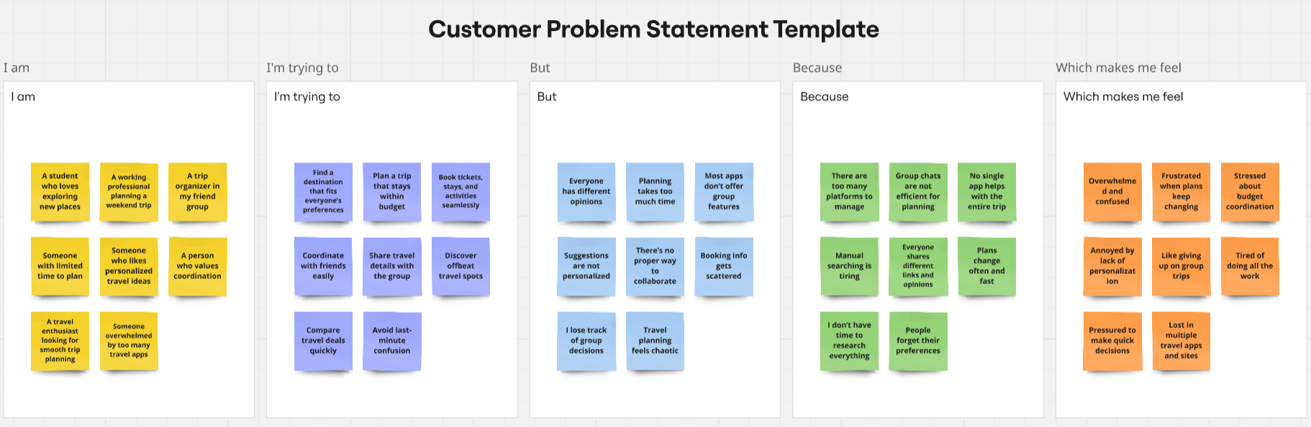

| **Problem Statement (PS)** | **I am (Customer)** | **I’m trying to** | **But** | **Because** | **Which makes me feel** |
| --- | --- | --- | --- | --- | --- |
| PS-1 | a frequent traveler who wants to discover and book flights quickly. | compare multiple flights, check offers, and book a flight within my budget. | most travel platforms are cluttered, lack personalization, and require switching between different apps for planning and social interaction. | they are either focused solely on booking or don’t integrate community features. | frustrated and overwhelmed during the travel planning process. |
| PS-2 | a solo traveler looking to connect with like-minded travelers. | find travel buddies, share trip updates, and get suggestions for destinations. | there’s no dedicated platform that combines travel booking with social networking. | existing apps are either travel-oriented or social platforms but not both. | isolated and less motivated to explore new places alone. |